Preliminary Analysis

# Analysis to be done:

1. Checking the number of individuals available from baseline (Considering ADNI1 and ADNI2 as baseline PHASE and then choose the one with more longitudinal samples).
2. Tracking diagnosis changes over time and determining the exact count of transitions
   1. CN 🡪 MCI
   2. MCI 🡪 AD
   3. Non-converters (remained CN)
3. Assessing the NPI-Q data availability for all the participants
   1. Providing the sample count for each subgroup (Mild, Moderate and Severe)
4. Checking and confirming the number of visits for these participants
   1. Number visits for each participant

# Results:

1. Baseline:

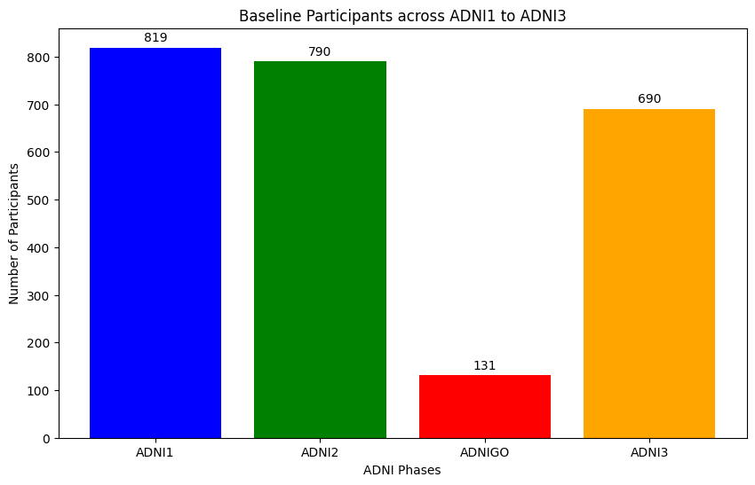

The ADNI1 has the highest participant count of 819 while, the ADNI2 has 790 participants starting from Baseline.

However, the Max Longitudinal Follow-ups (Number of visitations) is the highest for ADNI2:

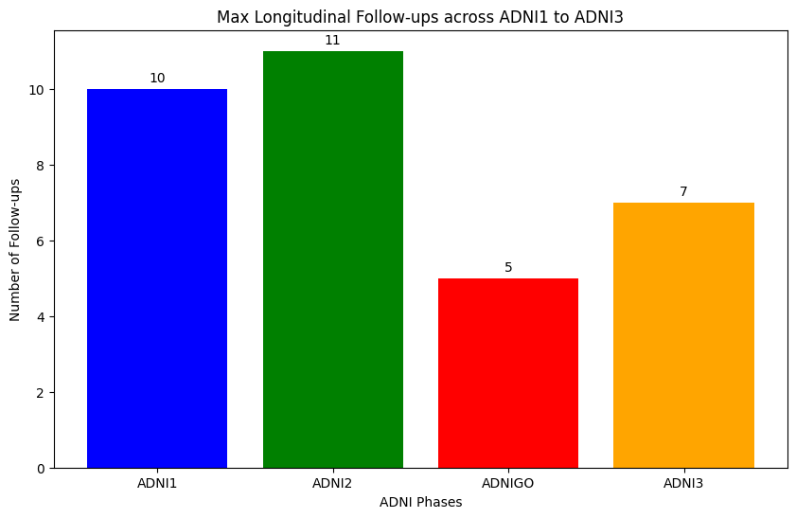

Since it is a longitudinal study, ADNI2 is likely the better choice due to its highest number of follow-ups. While ADNI1 provides a larger initial samples, longitudinal analysis benefits more from having extended follow-up data track.

1. Diagnosis changes over time:

Considering ADNI2 as the baseline phase (Total number of participants = 790),  
the baseline Diagnosis split were:  
AD 151

CN 188

EMCI 181

LMCI 164

SMC 106

The transitioned summary:

|  |  |  |  |
| --- | --- | --- | --- |
| DX_bl | Total Participants | Transitioned | Stable |
| AD | 151 | 148 | 3 |
| CN | 188 | 25 | 163 |
| EMCI | 181 | 179 | 2 |
| LMCI | 164 | 163 | 1 |
| SMC | 106 | 106 | 0 |

Where, in the SMC (Subjective memory complaints) group, individuals split (Current DX):   
CN 106

Dementia 4  
MCI 22

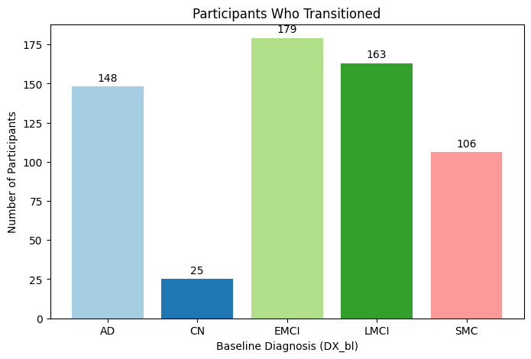

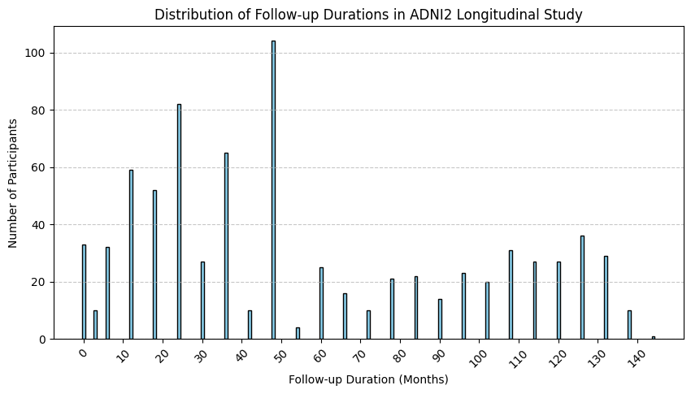Conclusion:  
Considering the ADNI2 as baseline, there are 790 participants with the most Follow-up duration.

1. Assessing the NPI-Q subgroups (Mild, Moderate and Severe):

Total ADNI2 Participants: 790

Participants with Available NPI-Q Data: 732

Participants without NPI-Q Data: 58

In which, the severity counts are:   
Mild: 174  
Moderate: 83  
Severe: 15

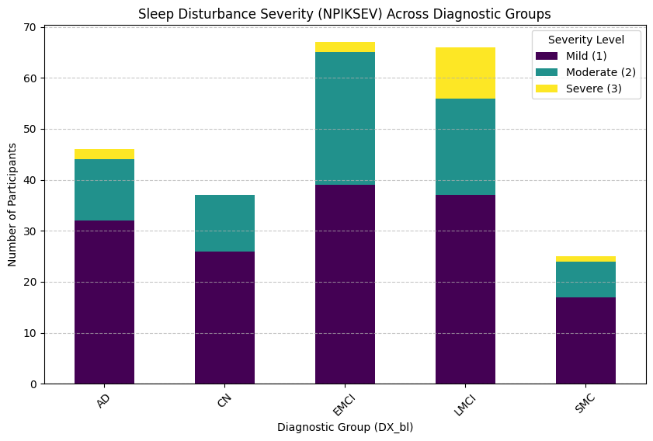The Sleep complaints such as awakening during the night, rising too early in the morning or excessive daytime napping were also grouped:   
No complaints: 650

Yes: 214  
not given: 6

From which,

Mild severe: 151  
Moderate severe: 75  
Highly severe: 15

Are given (Considering people have sleep complaints and complaints not given).

1. Number of Visits for all the 790 participants:

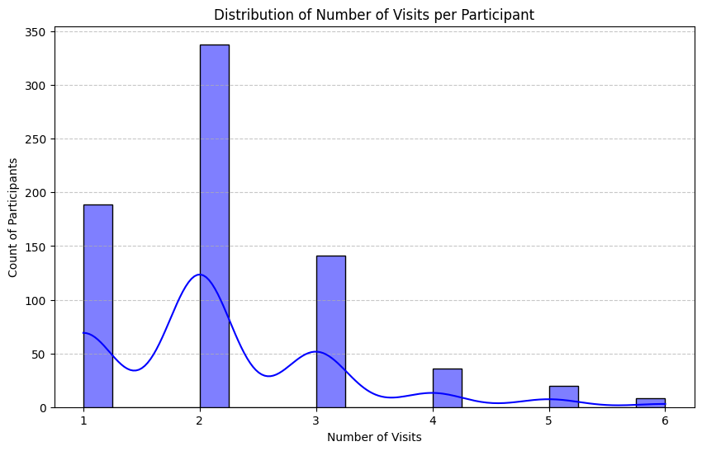The Maximum participants have atleast 2 visits.

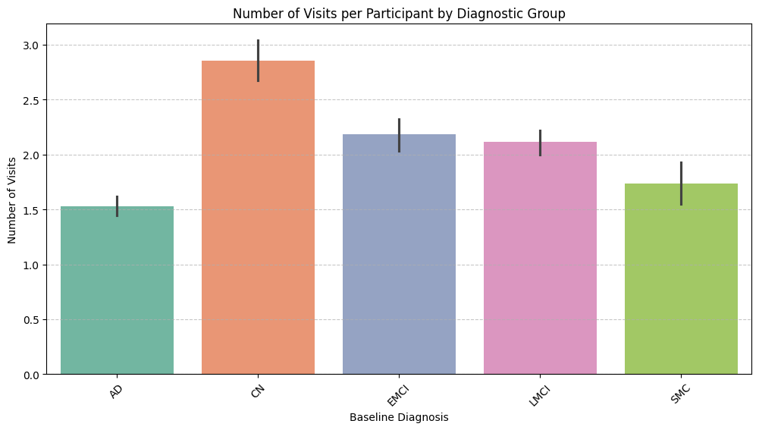Wherein the maximum number of visits are for the CN (Diagnosed during baseline), which is to be 6.

Conclusion: The median number of visits varies across diagnostic groups.